

FACULTY OF TECHNOLOGY AND ENGINEERING
DEVANG PATEL INSTITUTE OF ADVANCED TECHNOLOGY AND RESEARCH

DEPARTMENT OF INFORMATION TECHNOLOGY

A.Y 2026-27 Semester-3

LAB MANUAL

CSUC201: Fundamentals of Data Structure and Algorithms



Practical 8
Practical AIM:
To implement binary tree traversals and binary search tree insertion, and develop the ability to reason about how the order of visiting nodes changes the information retrieved from a tree.
Practical 8.1
Problem definition:
A company stores its organizational hierarchy as a tree — the CEO at the top, managers below, and employees at the leaves. Different departments need the hierarchy printed in different orders: HR wants each manager printed between their left and right sub-teams, the archive department wants each manager printed before their sub-teams, the payroll department wants each manager printed after all their sub-teams are listed, and the floor manager wants everyone printed level by level from top to bottom. Given a binary tree representing the hierarchy, implement all four printing orders and display the result of each.
Describe how your solution for level-by-level printing differs from the other three. What additional structure did you need to use, and why does the same recursive approach that works for the other three not directly apply here?
Problem faced:
I faced difficulty while implementing the four tree traversals because each traversal visits the root and its subtrees in a different order.
Solution:
I used recursion for inorder, preorder, and postorder traversal to visit the nodes in the required order. For level-order traversal, I used a queue to visit the nodes level by level, starting from the root.
Output:
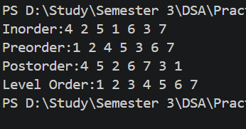

Practical 8.2
Problem definition:
A school library uses a system where every book is assigned a unique code when it arrives. Books are organized so that at any shelf position, all books to the left have smaller codes and all books to the right have larger codes. This arrangement lets staff find any book quickly by always knowing which direction to look. Given a sequence of book codes arriving one by one, insert each into the correct position and print the inorder sequence after all insertions are complete.
Describe how your solution decides where to place each new book code. What property of the final inorder sequence tells you whether all insertions were performed correctly?
Problem faced:
I faced difficulty while inserting book codes into the correct positions because each new value had to follow the Binary Search Tree property.
Solution:
I compared each new code with the current node. If the code was smaller, I moved to the left subtree; if it was larger, I moved to the right subtree. I used inorder traversal to display the codes in sorted order.
Output:
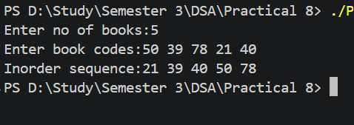
Key Questions
1. [Problem 1] Preorder traversal always visits the root before anything else. Using only this property — without tracing any tree — explain whether it would be possible to reconstruct the original tree from its preorder output alone, and what additional information you would need if it is not.
ANS:
No, preorder output alone is generally not enough to reconstruct the original binary tree uniquely. We also need inorder traversal or additional information about the tree's structure, such as markers for null children. This information helps identify the left and right subtrees correctly.
2. [Problem 2] The inorder traversal of a correctly built BST always produces a sorted sequence. If your inorder output is not sorted after all insertions, what does that tell you about where the error is — in the insertion logic, the traversal logic, or possibly both? How would you isolate which one?
ANS:
If the inorder output is not sorted, there may be an error in the BST insertion logic, the traversal logic, or both. First, I check whether each value is inserted according to the BST property. Then, I test the inorder traversal on a small, manually created BST. If the insertion is correct but the output is still unsorted, the traversal logic needs to be checked.
Github link:
https://github.com/dhanvi-219/FDSA/tree/main/Practical%208

